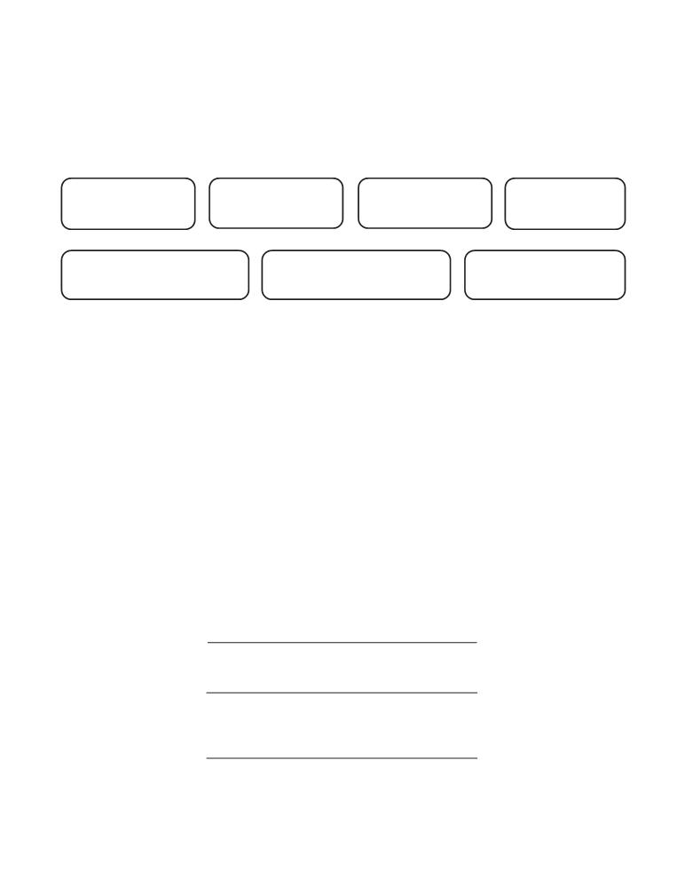

LEA RECOMMENDATION FOR DESIGNATION AS
“HIGHLY QUALIFIED”
For use by school units only.

last name first name middle name maiden name

social security number school unit and number telephone number of
personnel officer

It is the responsibility of the employing LEA to follow the NCLB criteria for establishing that a teacher is “highly qualified.” The accountability for the recommendation provided on this form, should there be a federal audit, rests with the LEA.
The above teacher meets the NCLB “highly qualified” criteria for the licensure area

(please provide area and license code)

based on the following (check applicable item):

Met testing in the area based on NC testing requirement
Met testing in the area based on another state’s testing requirement (specify state: )
Undergraduate academic major
Coursework equivalent to an academic major
Graduate degree
Master’s level licensure or above
NBPTS Certification

LEA

Signature of Superintendent or designated Personnel Administrator

Date

Public Schools of North Carolina
State Board of Education
Department of Public Instruction
Licensure Section
6365 Mail Service Center Form HQ-1
Raleigh, North Carolina 27699-6365 March 2006

