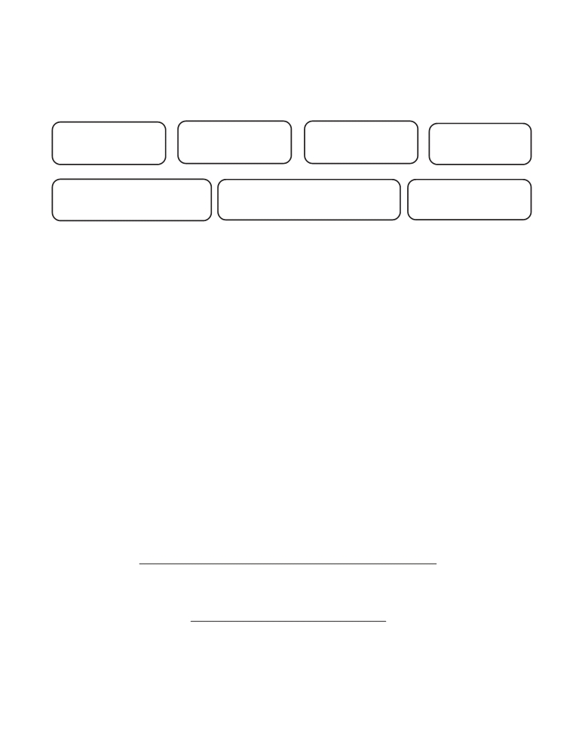

EXTENSION OF A TEMPORARY PERMIT
Please print or type

last name first name middle name maiden

social security number school unit unit number

SBE Policy effective July, 2001
The Licensure Section may issue a temporary permit to individuals who have not met testing requirements but otherwise qualify for a license. The permit is valid for the school year during which the license is established. The permit may be extended for a second year of teaching provided the individual has at least taken the required exams during the first year of teaching. Effective July 1, 2006, temporary permits will not be issued for teaching at the elementary level or for teaching core academic subjects at the middle or high school levels.

Check as appropriate:

The above individual received their first temporary permit for the
school year. Please grant a one-year extension for the school year
to satisfy testing requirements.

The efforts of the individual to satisfy testing requirements have been documented.

Note: A $55.00 processing fee is required for this action.

Superintendent (or designee)

date

Public Schools of North Carolina
State Board of Education
Department of Public Instruction
Licensure Section
6365 Mail Service Center Form ETP
Raleigh, North Carolina 27699-6365 March 2006

